We will need all these to import
from airflow.sdk import DAG
from datetime import datetime, timedelta
# from airflow.operators.python import PythonOperator
# from airflow.sensors.filesystem import FileSensor
# from airflow.operators.email import EmailOperator old outdated
from airflow.providers.standard.operators.python import PythonOperator
from airflow.providers.standard.sensors.filesystem import FileSensor
from airflow.providers.smtp.operators.smtp import EmailOperator
#---IMPORTING ALL FUNCTIONS FROM EXTERNAL FILES---#
from etl.extract import extract as extract_data
from etl.load import dump_to_mysql
from etl.transform import transform_data
from etl.load_google_sheet import load_to_google_sheet

shared dag dag folder with all the required files
to run it we will Need to move etl_dag.py in the airflow > dags> here
this is our main file in which we are calling all the function for individual tasks
then we will need to create a folder “etl” in dags where we will create all files having functions for individual task
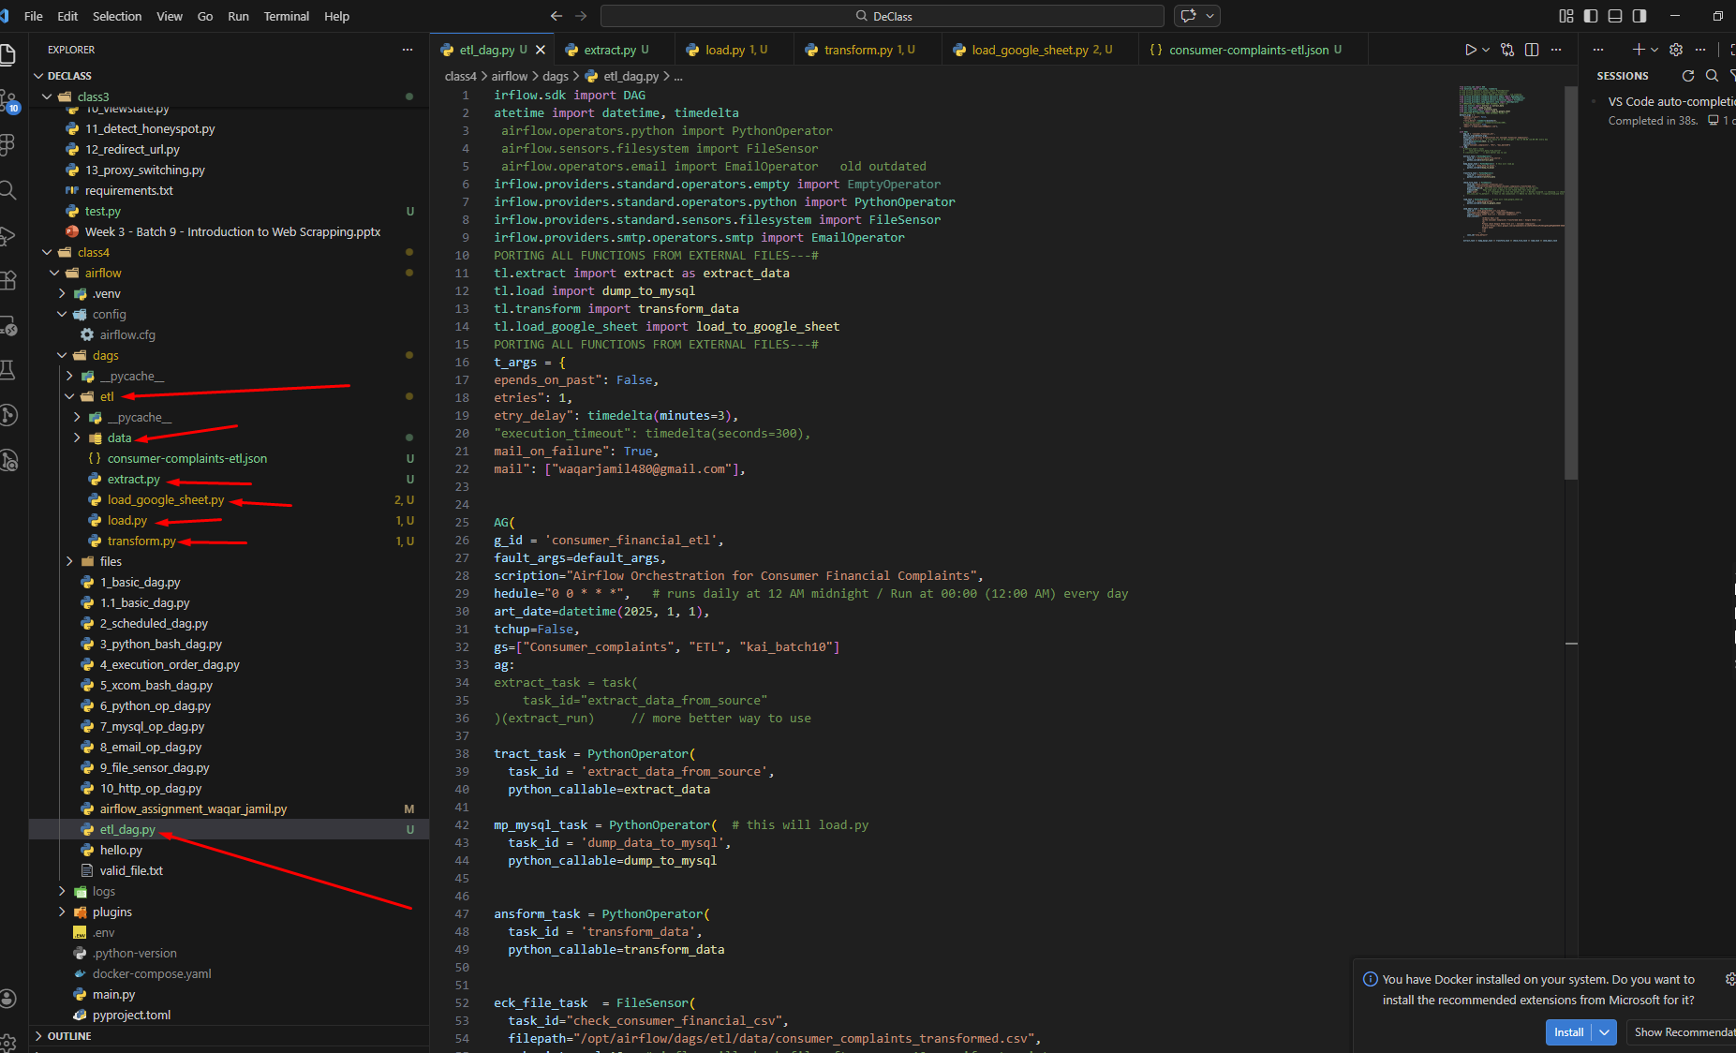
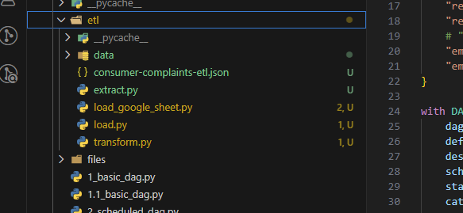

Task1 : Extract and Schedule Data for this extract.py
Task 2: Dump Raw Data to MYSQL Database for this load.py
Task 3: Transform and Summarize Data (Save into CSV) for this transform.py
Task 4: Add sensor to wait for the csv file to be created we have added this in main etl_dag.py file
Task 5: Dump Data to Google Sheets (Reading from CSV) for this load_google_sheet.py and for this task we will need a key/json file for the authentication for this we will create our account on https://console.cloud.google.com/ and then we will create a new project here then we will enable the google sheet api. After downloading the json file we will import that in this load_google_sheet.py
Like in this case we have: consumer-complaints-etl.json
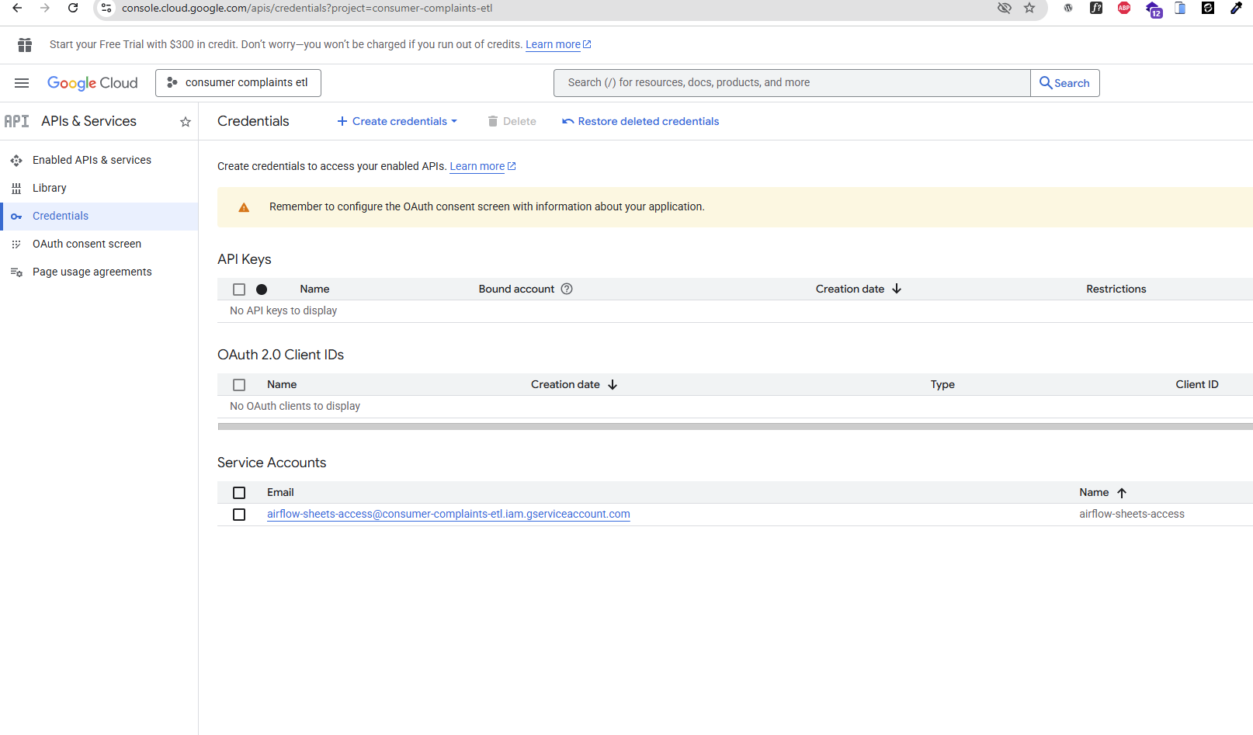

Here in this json file will be an email to which we will use to assign access to our google sheet which we will create manually and then we will assign that email for access and to update the data
Code will create 2.csv files when it will execute properly in the folder of data and will add data in table of my sql databases and will check file sensor and then it will update the google sheet from the data of transformed data
And then in final in it will send the email to use for that final online transformed data sheet url
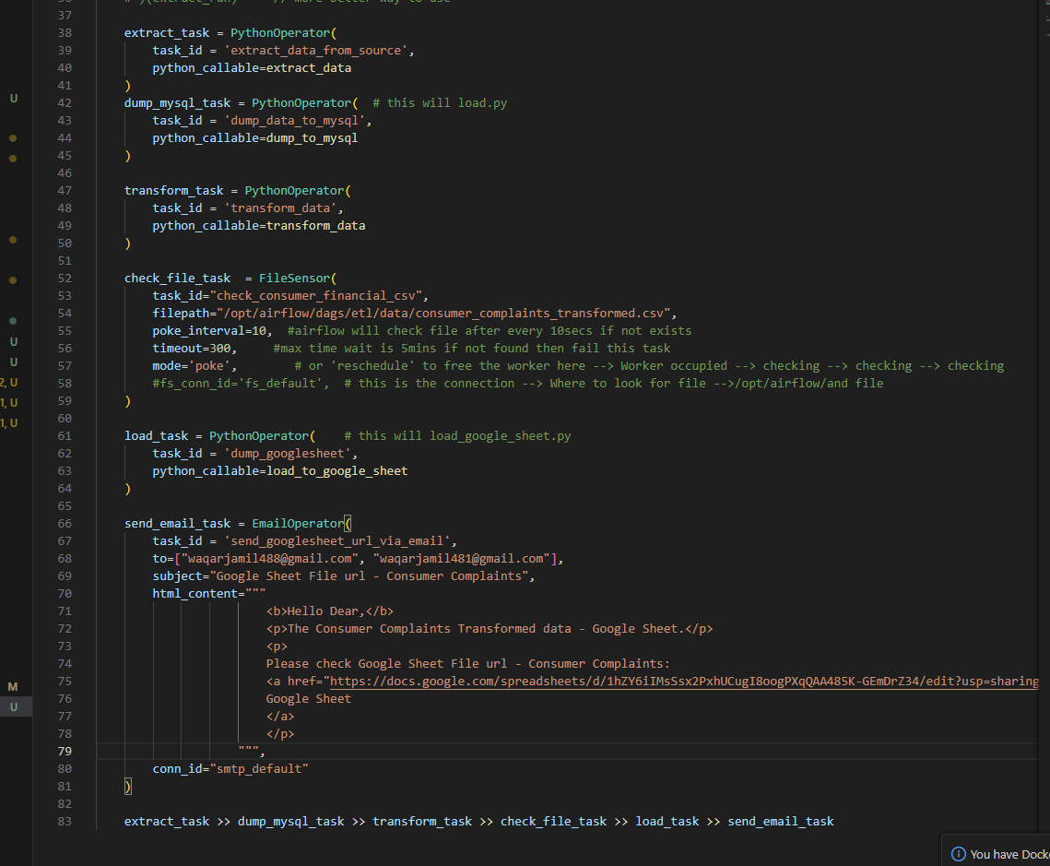
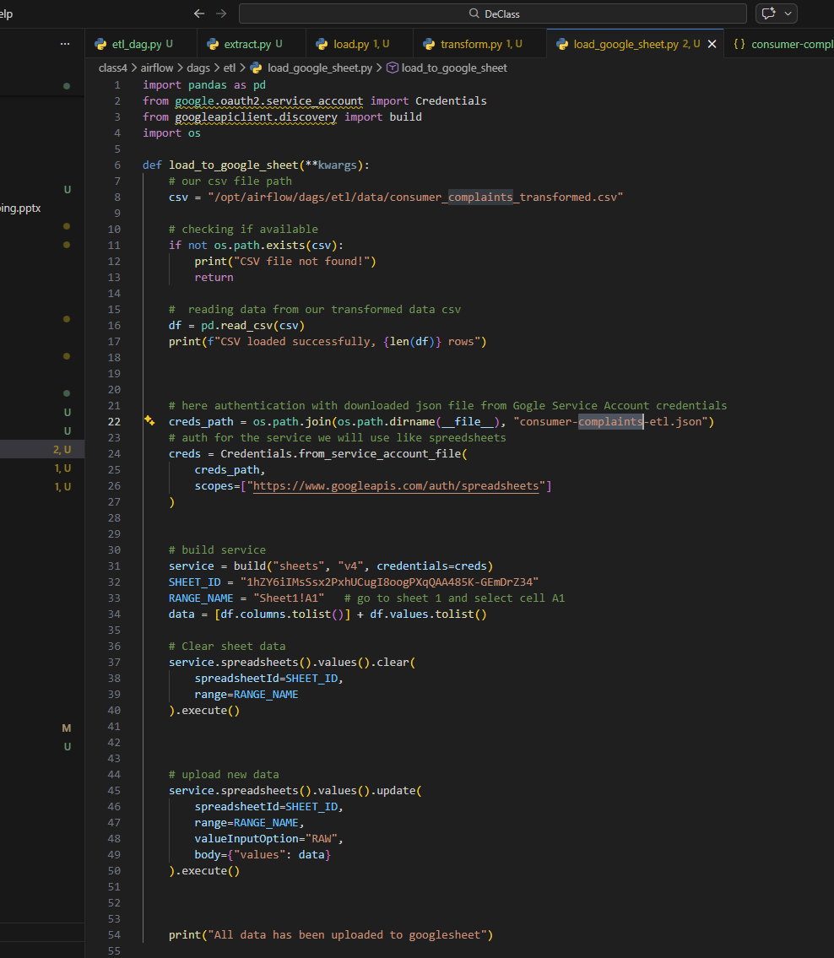
Some screenshot of code and already shared all details in video
https://www.loom.com/share/f7d457a72ac6400587ac5ac9cb64ff07
